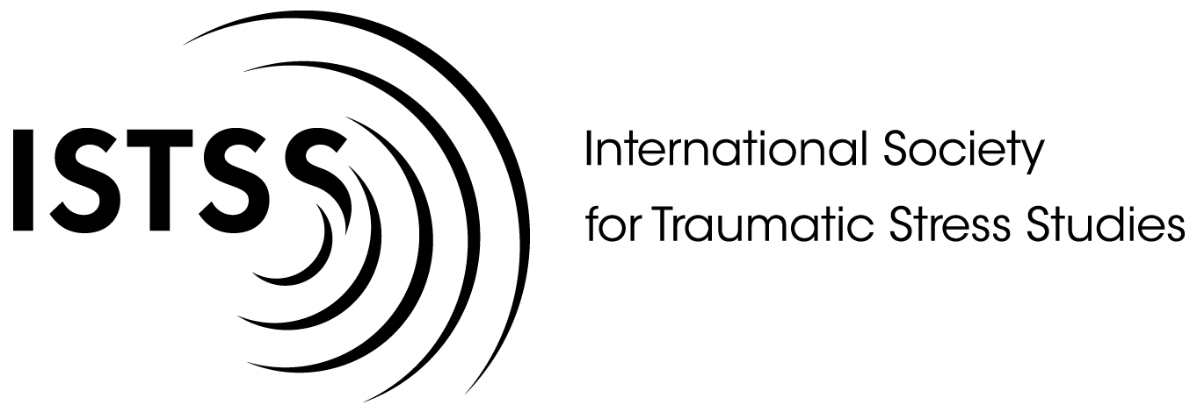

ISTSS AWARD NOMINATION FORM

Date submitted:

Person submitting nomination:

AWARD (please check one)
- Innovation Award
- Award for Outstanding Service to ISTSS
- Chaim and Bela Danieli Young Professional Award
- Robert S. Laufer, PhD, Memorial Award for Outstanding Scientific Achievement
- Sarah Haley Memorial Award for Clinical Excellence

NOMINEE INFORMATION

Candidate names and award committee deliberations are confidential. Nominees are not contacted by ISTSS unless they are selected by the Board as an award recipient.

Name of individual or group:

Email:

Phone:

Mailing address:

PLEASE CHECK ONE:

If self-nomination:
- I affirm that I have demonstrated integrity in my professional activities, including research, clinical practice, and advocacy.

If nomination of other(s):
- I affirm that to the best of my knowledge the nominee(s) demonstrate/s integrity in his/her/their professional activities, including research, clinical practice, and advocacy.

